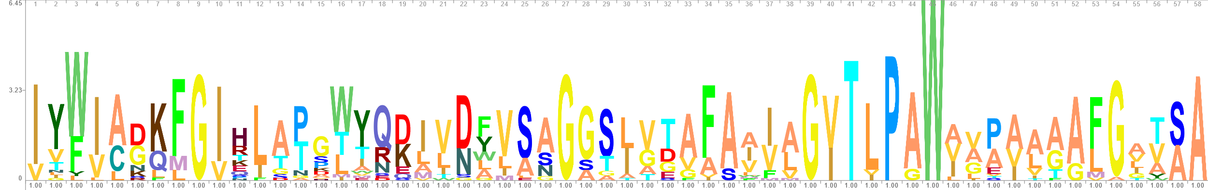
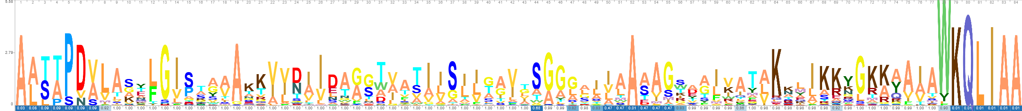
Fig S4: Sequence logo generated using Skylign after Clustal Omega alignment. The top logo shows family IIc i. The bottom logo shows family IIc ii. IIc i has a sequence length of 84 due to the sequence variation within the family, resulting in a gapped alignme
IIc i
IIc ii

